Create a simple cloud software application for Car Booking Reservation System using any Cloud Service Provider to demonstrate SaaS include the necessary fields such as search for cabs, from, to, rental , out station, Package type, hours/Days etc.
AIM:
To Create a simple cloud software application for Car Booking Reservation System using any Cloud Service Provider
PROCEDURE:
STEP 1:
Open browser and get into zoho ceator. Then sign in and click “Create application”. Below given screenshot will appear, hear type the application name of your Aim.

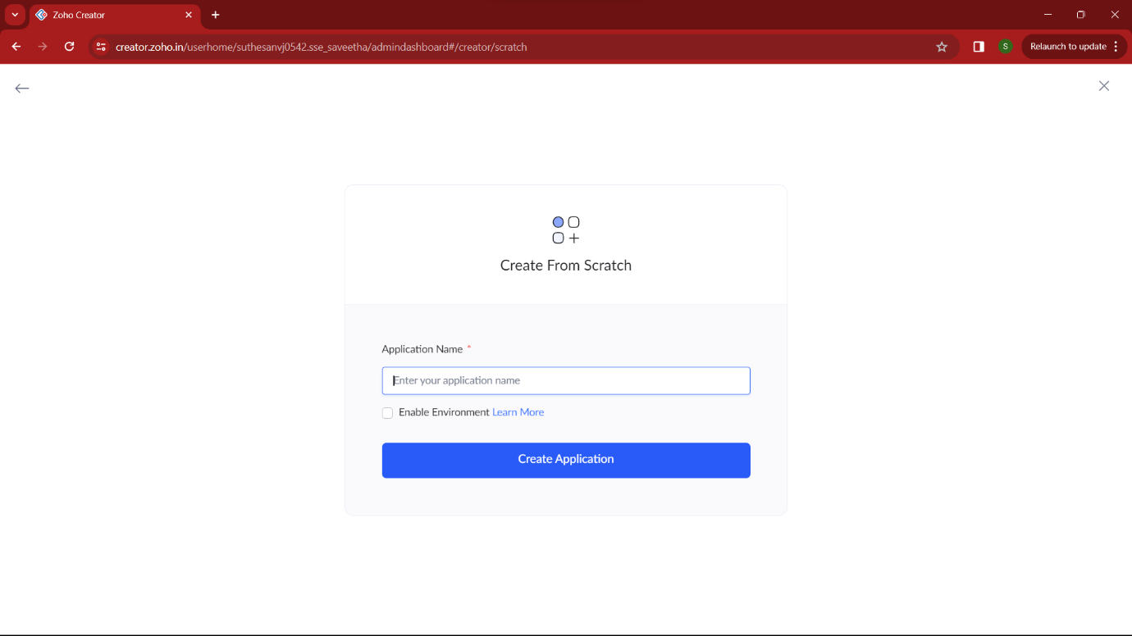

STEP 2:
Then select “start from scratch” option and select the proper component from the 4 components listed. For my application I just selected “forms” for the login credentials.
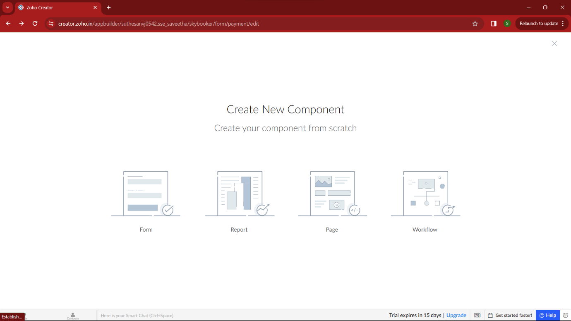

STEP 3:
In forms, below given options will be given. From here we can get sample templates of our requirements, otherwise we can import already saved schema for our application. I just selected “ from scratch” option for my application.
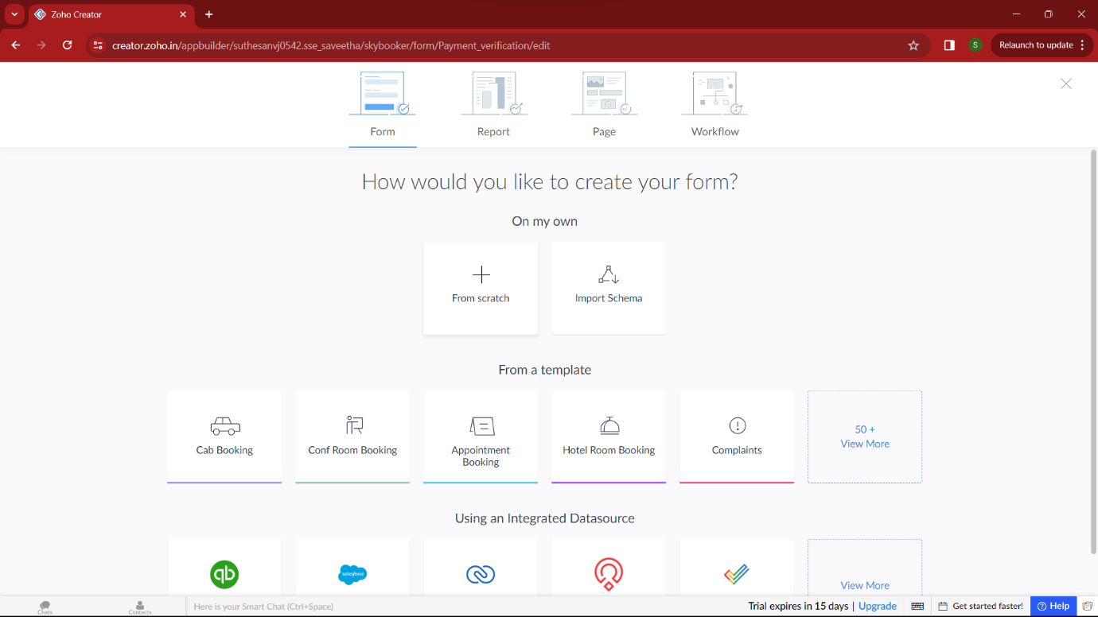

STEP 4:
Then provide an appropriate name for our application in the name form which shown below. I gave “DriveEase” for my “Car booking reservation system”

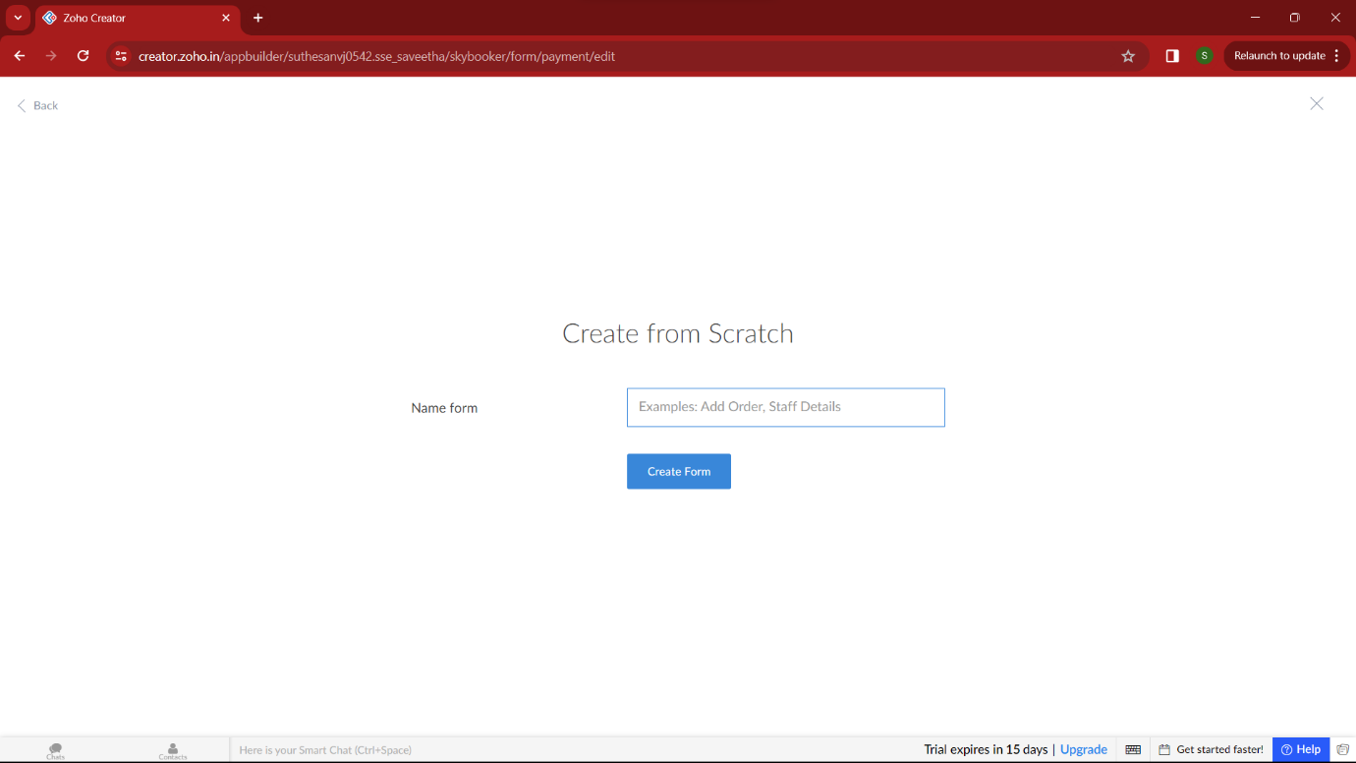

STEP 5:
by clicking “+” symbol shown in the picture given below, we can add number of forms in our application. Firstly I placed login form in my application with the essential credent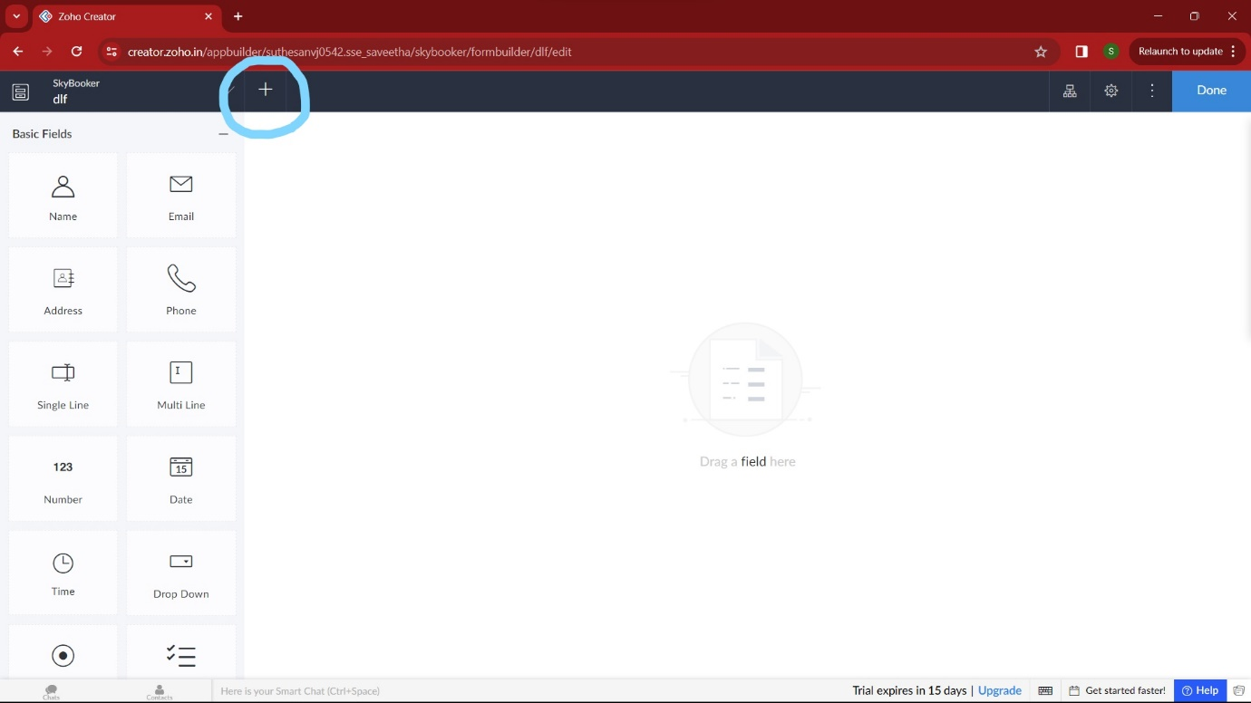
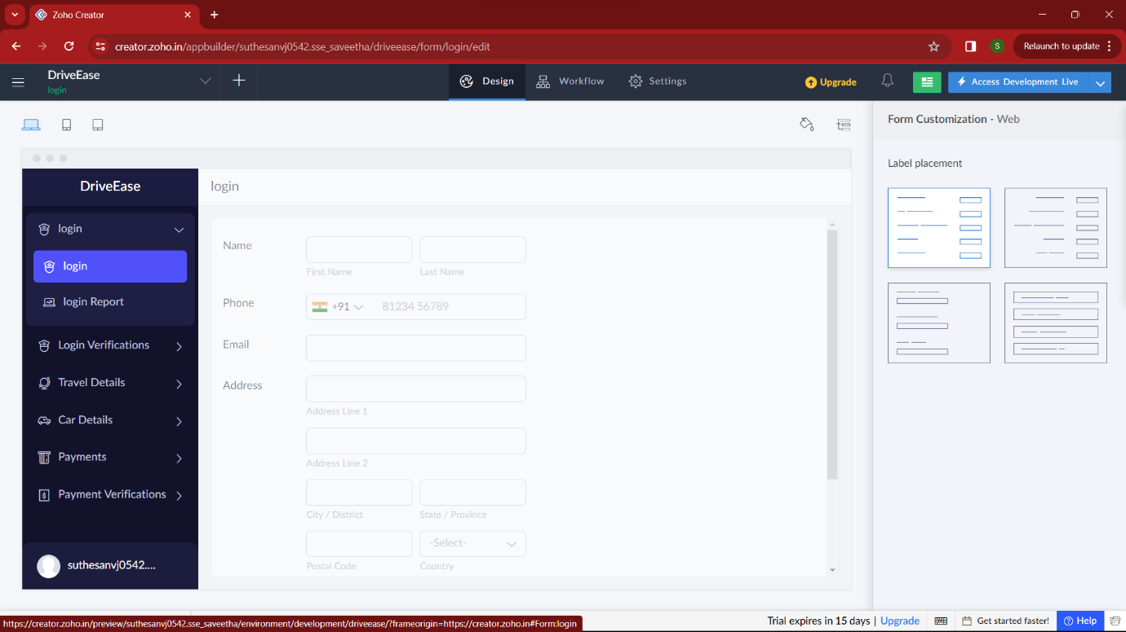

STEP 6:
Then I added another form namely login verification. It verifies user by getting the correct OTP from user, if wrong it takes the user again to the login section/ allow to resend the OTP.
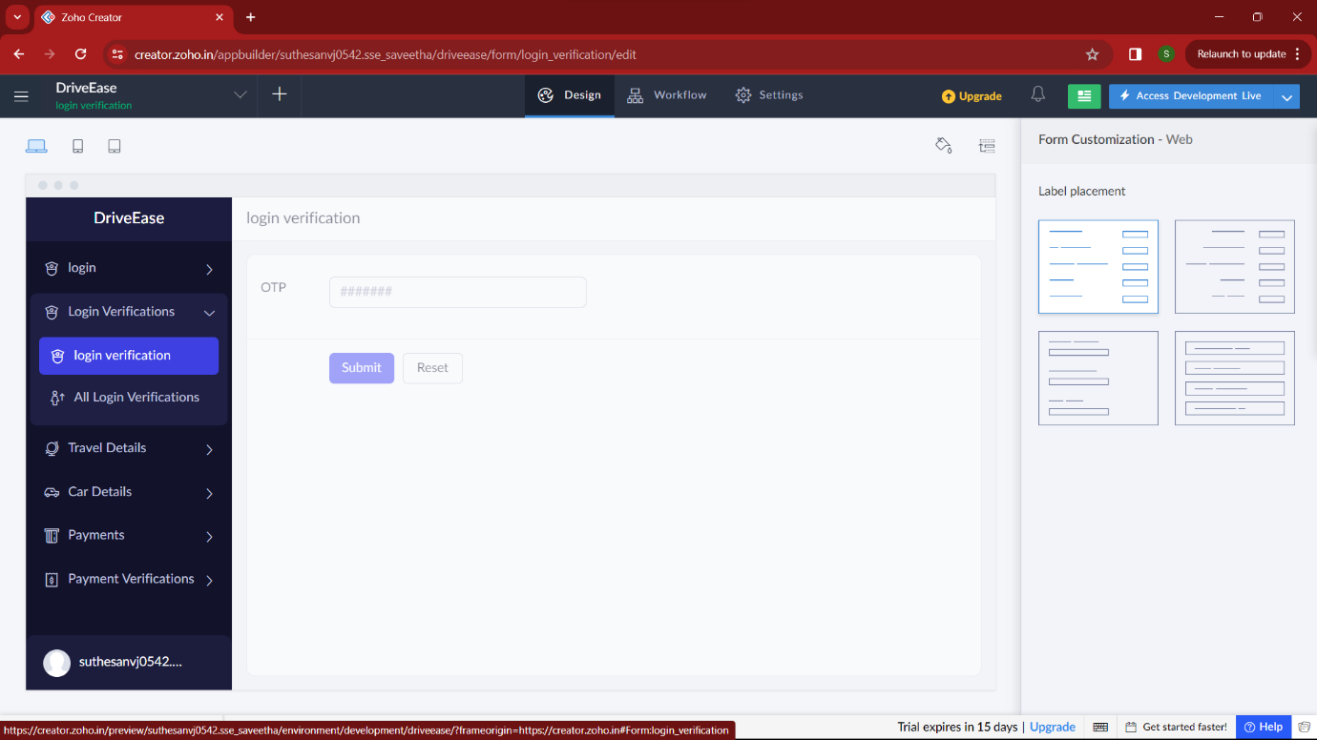

STEP 7:
Then I added another form namely “Travel detail” which gets all the necessary detail of the trip to provide the required car. By these our application can find the appropriate car from the requirements.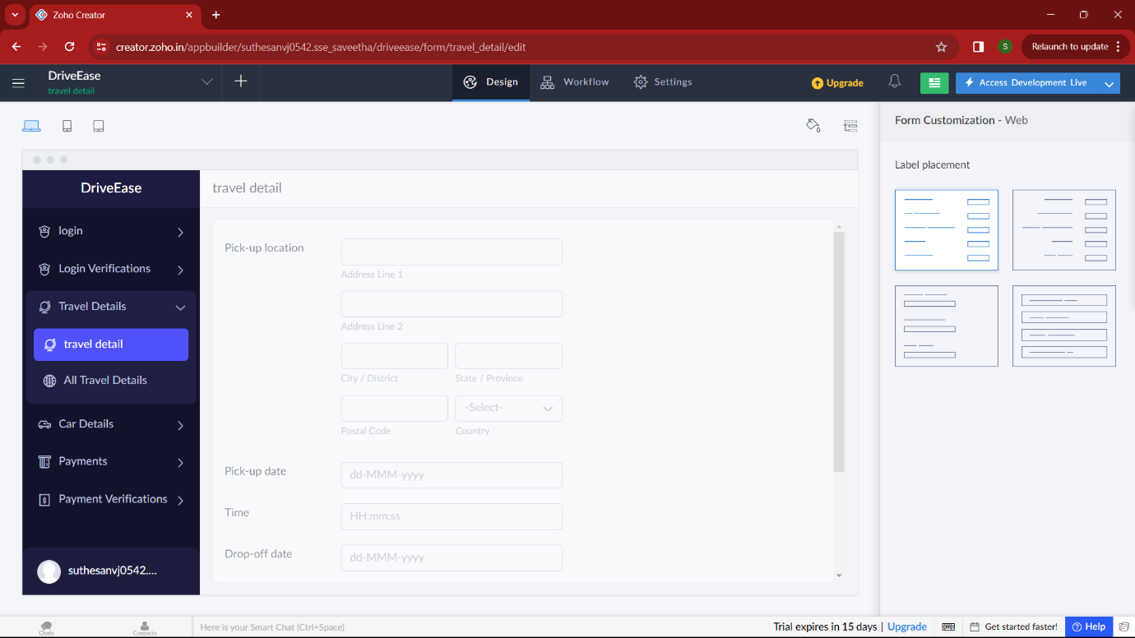

STEP 8:
Then in the next form I added “car details” of the selected thing. Here user can get the required data of selected car. He can also get the owner contact detail also.
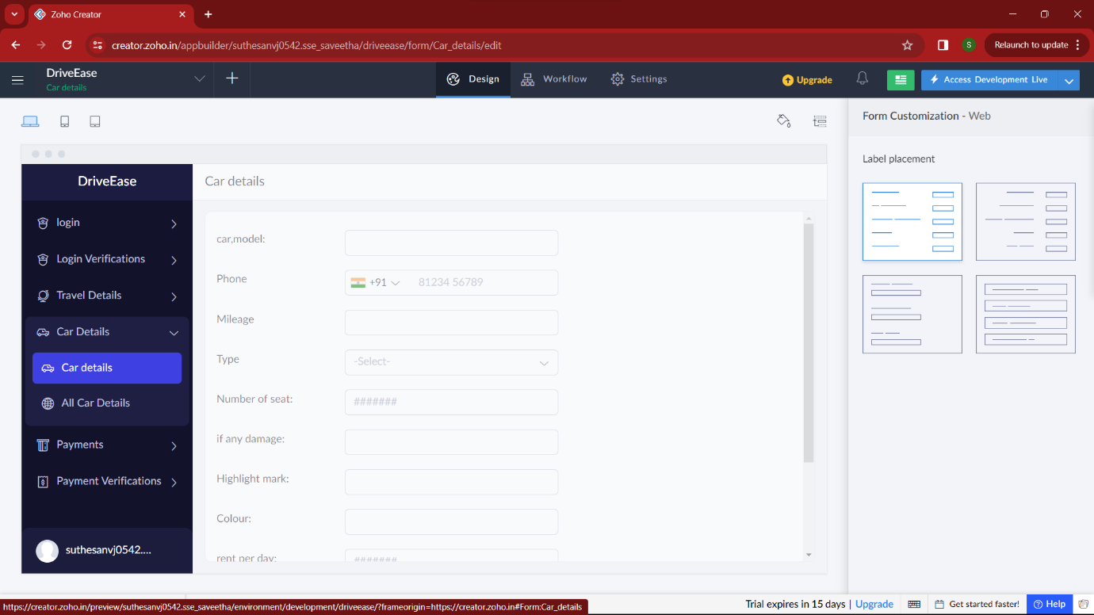

STEP 9:
In this form , the user select thepayment method and pay the amount.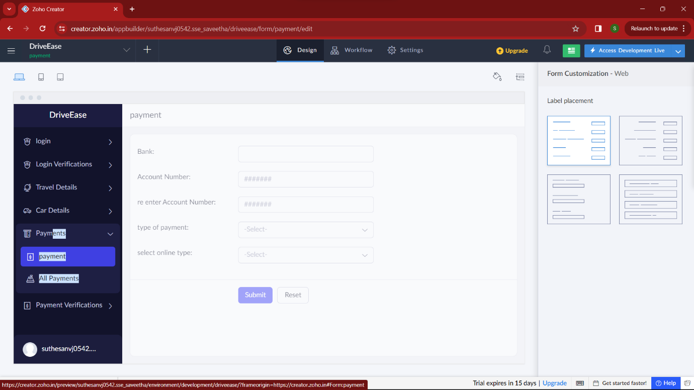

STEP 10:
in this form I included “payment verification” which is verified by the OTP entered by the user during the payment.

